Resources for students, parents/carers:

 www.familylives.org.uk 0808 8002222

 www.ceop.police.uk

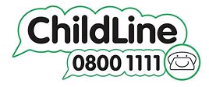 www.childline.org.uk

www.papyrus_uk.org


 www.themix.org.uk

 www.mermaidsuk.org.uk 0808 8010400

www.youngminds.org.uk 0808 8025544

www.nspcc.org.uk 0808 8005000

www.beateatingdisorders.org.uk 0808 8010677

Apps (free to download self help tools)


